**Plagiarism**

**I. Definition**

Plagiarism is simply the illegitimate appropriation of work or ideas attributed to other people. Plagiarism is often unintentional and can be avoided by adopting good working methods. Whether intentional or not, plagiarism is considered a serious offense in the academic world.

Any intellectual or artistic work (book, article, photography, painting, music, etc.) belongs to the person who created it, the author. Even if this work is published or put online on the Internet, it remains the property of its author and cannot be used without his authorization or without his being cited. Using an author's work without crediting them amounts to infringing on their copyright.

**II. Examples of plagiarism**

* Copy verbatim a passage from a book, magazine or web page without putting it in quotation marks and/or without mentioning the source
* Insert images, graphics, data, etc. into a work. from external sources without indicating the origin
* Summarizing an author’s original idea by expressing it in their own words, but failing to indicate the source
* Translate partially or completely a text without mentioning its origin
* Using another person’s work and presenting it as your own (even if that person has given their consent)
* Buy work on the “Web”
* The use of: particular data, an argument or a reference, an artistic production, statistics, diagrams, etc. without reference to their sources and their authors.
* The registration of any person of his name in a scientific work without participating in its development.
* The registration of the name of a renowned researcher without having participated in the production of the work, with or without his authorization, in order to help in the publication of the work.
* Bear the names of experts as members of scientific committees (seminars, journals, etc.) without their written opinions and commitments and without their effective participation in the work of the committees.
* Entrust the carrying out of scientific work to students or other people to adopt them in a research project, work, publication…….
* The use of students’ work and their dissertations as communications or publications of scientific articles.

**III. How to avoid plagiarism?**

* In order to avoid accidental plagiarism, a certain number of measures must be respected:
* Always keep the source when taking notes;
* Indicate each time in your own notes whether it is a quote or your interpretation;
* Imagine a first plan without sticking too close to your notes;
* Compare your work with the original sources;
* Learn to cite correctly by drawing inspiration from work appropriate to your field;
* Always cite your sources – but avoid an abundance of excerpts requiring citation, which indicates that you are not adding original work;
* Regularly submit extracts from your research paper or dissertation to your research director;
* Clearly flag excerpts that appear questionable at any time: even if plagiarism goes unnoticed in a draft, it is more likely to be detected when you submit the final version and you will be penalized just as severely.

In a general way :

* Make sure you understand the documentation you are using.
* Avoid relying too much on the ideas of others.
* Make sure you know how to quote someone correctly.
* Avoid any contact with “dissertation factories” available on the Internet.

You should always mention the sources you use. Cite correctly when:

• You borrow documentation, ideas, arguments, graphs, maps, illustrations, etc.

• You reproduce a passage. If you mention a source, you must cite verbatim.

• You paraphrase or summarize ideas or arguments.

• You present facts that are not “widely distributed” or notorious.

**IV. How is plagiarism detected?**

There are different ways for a teacher to detect plagiarism in work submitted.

a) By careful reading during the evaluation of the work; several clues can alert you: change in the writing style of the rendering, absence of references, etc.

b) By using software that will detect similarities between the student's text and texts available online, etc. This software will provide the teacher with an analysis report on the “similar” elements found.

Anti-plagiarism software has a major advantage: it automates the plagiarism detection and copy-paste process for universities. It highlights plagiarized passages by highlighting them and providing a list of sources that the student used.

Anti-plagiarism software has the ability to scan your copy and indicate which passages have been plagiarized: it's quick and simple. The plagiarism detector searches for similarities between a document submitted for analysis and documents accessible on the Internet or present in the university's own reference base.

**V. Plagiarism control measures**

* Establishment of a database, on the website of each establishment, containing all the work carried out by students and teacher-researchers: dissertations, theses, internship reports, research projects, publications, etc.
* Establishment of a database, on the website of each establishment, containing the names of teacher-researchers, their sectors, specialties, area of ​​scientific interest, CV, etc. in order to benefit from their experiences for the evaluation of the scientific research activities.
* Purchase of computer program rights, or software design, plagiarism detectors
* When registering the research theme (thesis, dissertation), students and teacher-researchers must sign a scientific integrity commitment (outline).

**VI. Sanctions**

A student found to be a fraudster or plagiarist is liable to one or more sanctions. The wording will be placed in his file. When an act of fraud or plagiarism is noted, the teacher decides on the sanction to apply and notifies the department and the student. The possible sanctions are:

* Zero mark for the part of the work concerned.
* Zero score on the evaluation (mini project, exam, etc.)
* Failure of the course, if the weighted value of the work or the exam justifies it.

In the case of group work, students in the same group are responsible for the work submitted in the name of the group. If a member produces and submits work or part of work that turns out to have been plagiarized, all members of the team will receive a sanction. However, in the event that the teacher can ensure that the offense is committed by one or a few individuals only, he or she may apply the sanction to the latter only.

When the department receives a case, it examines the facts and supporting documents. Taking into account the seriousness of the offense and the repeat offense, it determines the disciplinary sanctions to be applied and notifies the student.

The possible sanctions are:

* Suspension from the university for a semester or even a year
* Expulsion from the university.

**Copyright**

**Introduction**

The Convention Establishing the World Intellectual Property Organization (1967) does not aim to define intellectual property but lists the following objects protected by intellectual property rights:

* Literary, artistic and scientific works;
* Performers' interpretations and performances, phonograms and broadcasts;
* Inventions in all areas of human activity;
* Scientific discoveries;
* Industrial designs and models;
* Trademarks, trade marks and service marks, as well as trade names and trade names;
* Protection against unfair competition; and all other rights relating to intellectual activity in the industrial, scientific, literary and artistic fields.”

It is in the Paris Convention for the Protection of Industrial Property of 1883 (Paris Convention) and in the Berne Convention for the Protection of Literary and Artistic Works of 1886 (Berne Convention) that the first time the importance of intellectual property protection. These two treaties are administered by the World Intellectual Property Organization (WIPO).

Countries have generally adopted intellectual property legislation for two main reasons:

• To give legal form to the rights of creators and innovators over their creations and innovations, while ensuring the public's right to access these creations and innovations;

• To promote creativity and innovation, thus contributing to economic and social development.

**I. Branches of intellectual property:**

Intellectual property is generally divided into two sectors: industrial property and copyright.

**I.1. Industrial property**

Industrial property takes a wide variety of forms, including patents, industrial designs (aesthetic creations related to the appearance of industrial products), product trademarks, service marks, layout designs of integrated circuits, trade names and commercial designations, geographical indications and protection against unfair competition.

**I.2. Copyright**

Copyright relates to literary and artistic creations, such as books, music, paintings and sculptures, films, and technology-based works (such as computer programs and electronic databases). ). This branch of law gave birth to two major systems, that of “copyright” and that of “author’s rights” proper.

The term copyright refers to the act of copying an original work which, with regard to literary and artistic creations, can only be carried out by the author or with his permission. The term copyright refers to the creator of an artistic work, its author, thus emphasizing, as most legislation recognizes, that authors have certain specific rights over their works that only they can exercise, which refer most often moral rights, such as the right to prevent any distortion of the work. Other rights, such as the right to make copies, may be exercised by third parties with the permission of the author, for example a publisher to whom the author grants a license for this purpose.

There are four types of works that are protected by copyright. They are summarized in the following figure: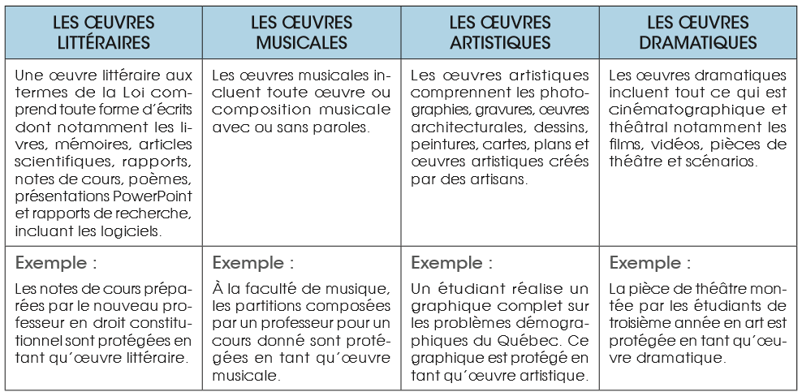

**I.2.1. Moral rights**

By definition, moral rights are attached to the person of the author. The latter thus enjoys the right to respect for his name, his quality and his work. Also, moral rights include the following rights:

- Right of disclosure

- Right of paternity

- Right to respect for the work

- Right to withdrawal and repentance

**\*The right of disclosure**

The right of disclosure applies to the author and his beneficiaries. It allows them in particular to decide on the public nature or not, the conditions and procedures for using a work signed by the author.

**\*The right of paternity**

The author also enjoys the right of paternity. Thanks to this, he can legally make himself known as the author of a work made public, under a pseudonym, under cover of anonymity or under his real identity. He may also prohibit any third party from usurping authorship of his work.

**\*The right to respect for the work**

As for the right to respect for the work, it covers the author if the latter opposes the modification of his work in any form whatsoever.

*The right of withdrawal and repentance

The right of withdrawal and repentance allows the author to terminate an exploitation contract and the distribution of his work following a transfer of rights contract. Even if he is not subject to any duty of justification, he will have to pay fair compensation to the concessionaire.

* **The prerogatives of the holders of these rights**

Moral rights are characterized by the fact that they are perpetual, inalienable, imprescriptible and elusive. Consequently, it persists even if the author or his heirs face debts, or if any contract has been signed. Also, the author cannot, under any circumstances, waive the exercise of this right.

It is impossible to assign one's moral rights. Indeed, any transfer or assignment clause of moral rights is void, due to its inalienable nature. On the other hand, the heirs of the author can actually enjoy the moral rights of the author of a work, because they are imprescriptible. Consequently, as long as the work has an existence in the artistic universe, moral rights can be exercised in the same way as the author would have enjoyed it during his lifetime.

**I.2.2. Property rights**

Property rights allow the author or his beneficiaries (his heirs) to exploit his work in any form whatsoever: thus, the author can decide on the reproduction and public representation of his work and benefit from it. A remuneration.

Unlike moral rights which are perpetual and inalienable, property rights are limited in time and can be transferred to a third party: the author has them throughout his life as do his beneficiaries for the 70 years following his death. .

Most copyright laws state that authors or other rights owners have the right to authorize or prevent certain acts in connection with a work. Rights holders can authorize or prohibit the following acts:

* The reproduction of the work in various forms, for example in the form of printed matter or sound recordings;
* The distribution of copies of the work;
* The public interpretation or performance of the work;
* Broadcasting or other communication of the work to the public;
* Translation of the work into other languages;
* The adaptation of the work, consisting for example of transforming a novel into a film script.