University of Bejaia

2nd year Technology

Lecture two: Electric circuit components

Lecturer: Miss Alkama

An **electronic component** is any basic **discrete device** or physical entity in an electronic system used to affect [electrons](http://en.wikipedia.org/wiki/Electrons) or their associated fields. Electronic components are mostly industrial products, available in a singular form and each one has a particular function.

1**. Electronic components**:

|  |  |
| --- | --- |
| Wire |  |
| Wires joined |  |
| Wires not joined |  |

|  |  |
| --- | --- |
| Cell |  |
| Battery |  |
| DC supply |  |
| AC supply |  |
| Fuse |  |
| [Transformer](http://www.kpsec.freeuk.com/powersup.htm#transformer) |  |
| Earth (Ground) |  |

|  |  |
| --- | --- |
| [Lamp](http://www.kpsec.freeuk.com/components/lamp.htm) |  |
| Heater |  |
| Motor |  |
| Bell |  |
| [Buzzer](http://www.kpsec.freeuk.com/components/other.htm#buzzer) |  |
| [Inductor (Coil, Solenoid)](http://www.kpsec.freeuk.com/components/other.htm#inductor) |  |

|  |  |
| --- | --- |
| [Resistor](http://www.kpsec.freeuk.com/components/resist.htm) |  |

|  |  |
| --- | --- |
| [Capacitor](http://www.kpsec.freeuk.com/components/capac.htm) |  |

|  |  |
| --- | --- |
| [Diode](http://www.kpsec.freeuk.com/components/diode.htm) |  |
| [LED Light Emitting Diode](http://www.kpsec.freeuk.com/components/led.htm) |  |

|  |  |
| --- | --- |
| Microphone |  |
| Earphone |  |
| [Loudspeaker](http://www.kpsec.freeuk.com/components/other.htm#loudspeaker) |  |
| Amplifier |  |
| Aerial (Antenna) |  |

|  |  |
| --- | --- |
| [Voltmeter](http://www.kpsec.freeuk.com/meters.htm#voltmeters) |  |
| [Ammeter](http://www.kpsec.freeuk.com/meters.htm#ammeters) |  |
| [Galvanometer](http://www.kpsec.freeuk.com/meters.htm#galvanometers) |  |
| [Ohmmeter](http://www.kpsec.freeuk.com/meters.htm#ohmmeters) |  |

|  |  |
| --- | --- |
| [LDR](http://www.kpsec.freeuk.com/components/other.htm#ldr) |  |
| [Thermistor](http://www.kpsec.freeuk.com/components/other.htm#thermistor) |  | |

**2. Component’s classification:**

A component may be classified as [passive, or active](http://en.wikipedia.org/wiki/Passivity_%28engineering%29). The strict physics definition treats passive components as ones that cannot supply energy themselves; whereas a [battery](http://en.wikipedia.org/wiki/Battery_%28electricity%29) would be seen as an active component since it truly acts as a source of energy.

* **Active components** rely on a source of energy and usually can inject power into a circuit. Active components include amplifying components such as [transistors](http://en.wikipedia.org/wiki/Transistor), triode [vacuum tubes](http://en.wikipedia.org/wiki/Vacuum_tube) (valves), and [tunnel diodes](http://en.wikipedia.org/wiki/Tunnel_diode).
* **Passive components** can't introduce net energy into the circuit. They also can't rely on a source of power, except for what is available from the (AC) circuit they are connected to. As a consequence they can't amplify (increase the power of a signal), although they may increase a voltage or current (such as is done by a transformer or resonant circuit). Passive components include two-terminal components such as resistors, capacitors, inductors, and transformers.

**Series and Parallel Circuits**

If the components of a circuit are connected in a single loop, so that the same current flows through all the loads then the connection is called 'series' circuit.

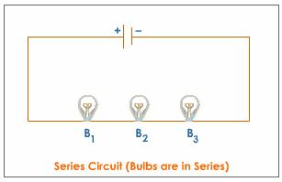

##### But, if each of the components has a separate connection with a battery, then the circuit is said to be in parallel. The potential difference across the elements remains same.

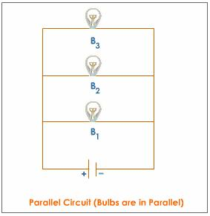

With each of these two basic circuit configurations, we have specific sets of rules describing voltage, current and resistance relationships.

**.Series Circuits**:

.Voltage drops add to equal total voltage.

.All the components share the same (equal) current.

.Resistance adds to equal total resistance.

.**Parallel Circuit**:

.All the components share the same (equal) voltage.

.Branch currents add to equal total currents.

.Resistance diminishes to equal total resistance.