University of Bejaia

Faculty of exact sciences

Department of computer science.

Module: technical English

Teacher: Ait Maten R.

Level: L2

Lesson 03: Computer Memory
Memory is major part of computers that categories into several types. Memory is best storage part to the computer users to save information, programs…. Etc. The computer memory offers several kinds of storage media some of them can store data temporarily and some of them can store permanently. Memory consists of instructions and the data saved into computer through Central Processing Unit (CPU).
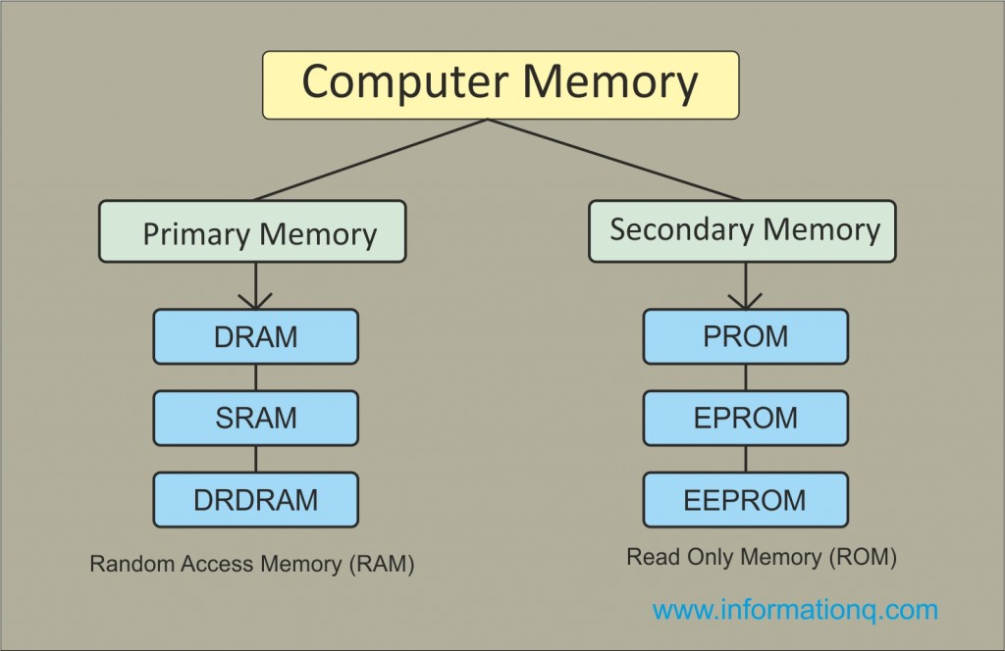

Types of Computer Memories:
Memory is the best essential element of a computer because computer can’t perform simple tasks. The performance of computer mainly based on memory and CPU. Memory is internal storage media of computer that has several names such as, majorly categorized into two types, Main memory and Secondary memory.
1. Primary Memory / Volatile Memory.
2. Secondary Memory / Non Volatile Memory.

1. Primary Memory / Volatile Memory:
Primary Memory also called as volatile memory because the memory can’t store the data permanently. Primary memory select any part of memory when user want to save the data in memory but that may not be store permanently on that location. It also has another name i.e. RAM.

Random Access Memory (RAM):
The primary storage is referred to as random access memory (RAM) due to the random selection of memory locations. It performs both read and write operations on memory. If power failures happened in systems during memory access then you will lose your data permanently. So, RAM is volatile memory. RAM categorized into following types.
- DRAM
- SRAM
- DRDRAM

RAM
RAM stands for Random Access Memory. The processor accesses all memory addresses directly, irrespective of word length, making storage and retrieval fast. RAM is the fastest memory available and hence most expensive. These two factors imply that RAM is available in very small quantities of up to 1GB. RAM is volatile but my be of any of these two types

DRAM (Dynamic RAM)
Each memory cell in a DRAM is made of one transistor and one capacitor, which store one bit of data. However, this cell starts losing its charge and hence data stored in less than thousandth of a second. So it needs to be refreshed thousand times a second, which takes up processor time. However, due to small size of each cell, one DRAM can have large number of cells. Primary memory of most of the personal computers is made of DRAM.

SRAM (Static RAM)
Each cell in SRAM is made of a flip flop that stores one bit. It retains its bit till the power supply is on and doesn’t need to be refreshed like DRAM. It also has shorter read-write cycles as compared to DRAM. SRAM is used in specialized applications.
DRDRAM
Direct Rambus Dynamic RAM is a memory subsystem that promises to transfer up to 1.6 billion bytes per second. The subsystem consists of the random access memory (RAM), the RAM controller, and the bus (path) connecting RAM to the microprocessor and devices in the computer that use it

2. Secondary Memory / Non Volatile Memory:
Secondary memory is external and permanent memory that is useful to store the external storage media such as floppy disk, magnetic disks, magnetic tapes and etc cache devices. Secondary memory deals with following types of components.

Read Only Memory (ROM) :
ROM is permanent memory location that offer huge types of standards to save data. But it work with read only operation. No data lose happen whenever power failure occur during the ROM memory work in computers.
ROM memory has several models such names are following.
1. PROM: Programmable Read Only Memory (PROM) maintains large storage media but can’t offer the erase features in ROM. This type of RO maintains PROM chips to write data once and read many. The programs or instructions designed in PROM can’t be erased by other programs.
2. EPROM : Erasable Programmable Read Only Memory designed for recover the problems of PROM and ROM. Users can delete the data of EPROM thorough pass on ultraviolet light and it erases chip is reprogrammed.
3. EEPROM: Electrically Erasable Programmable Read Only Memory similar to the EPROM but it uses electrical beam for erase the data of ROM.
Cache Memory: Mina memory less than the access time of CPU so, the performance will decrease through less access time. Speed mismatch will decrease through maintain cache memory. Main memory can store huge amount of data but the cache memory normally kept small and low expensive cost. All types of external media like Magnetic disks, Magnetic drives and others store in cache memory to provide quick access tools to the users.

