**Annex1**

**Deal-Grove Model**

The Deal-Grove model, developed by Deal and Grove in the 1960s, provides a mathematical framework for understanding the thermal oxidation of silicon. It describes the growth of an oxide layer on silicon substrates, primarily silicon dioxide (SiO₂), during oxidation processes. This model is particularly important in semiconductor manufacturing and integrated circuit fabrication.

**Key Assumptions of the Deal-Grove Model**

1. **Oxidation Mechanism**: The model assumes that the oxidation reaction occurs at the interface between the oxide and the silicon substrate rather than at the surface of the oxide layer.
2. **Steady-State Conditions**: The model operates under steady-state conditions, meaning that transient effects are not considered.
3. **One-Dimensional Transport**: The model simplifies the oxidation process to one dimension, assuming uniform conditions across the oxide layer.

**Stages of Oxidation**

The oxidation process can be divided into three main stages:

1. **Transport of Oxidant from Gas Phase to Oxide Surface**:
   * The oxidizing species (e.g., O₂ or H₂O) diffuses through the gas phase to reach the surface of the oxide layer.
   * The flux of oxidant can be expressed using Henry's law, which relates the concentration of a gas in a liquid to its partial pressure.
2. **Diffusion through the Oxide Layer**:
   * Once at the oxide surface, oxidants diffuse through the oxide layer towards the Si/SiO₂ interface.
   * This diffusion is described by Fick's law, which states that the flux is proportional to the concentration gradient.
3. **Reaction at Silicon Interface**:
   * At the Si/SiO₂ interface, oxidants react with silicon atoms to form silicon dioxide.
   * This reaction can be modeled as a first-order reaction with respect to oxidant concentration.

**Mathematical Formulation**

The fluxes associated with each stage can be represented mathematically:

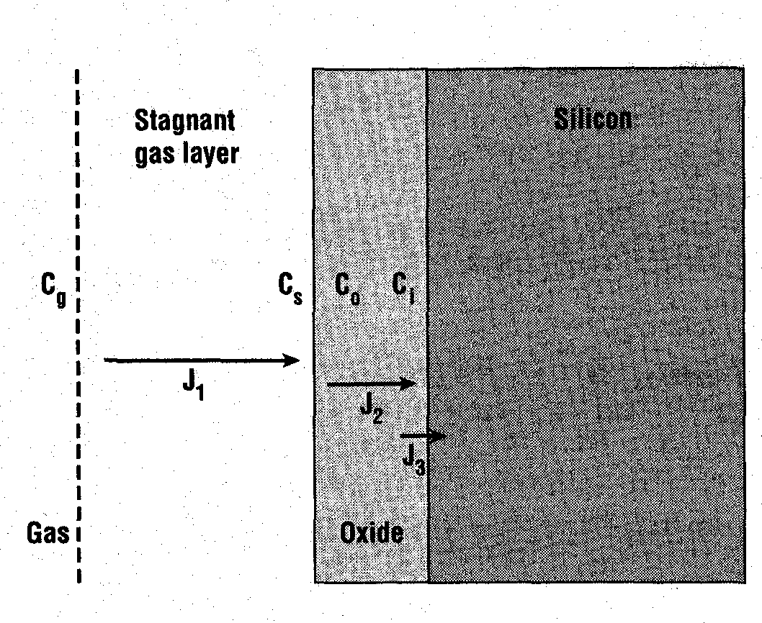

1. **Flux from Gas Phase ($J_{g}$ ​)**:

$$J_{1}=k_{g}⋅(C_{g}-C_{s})$$

where $k_{g}$ ​ is a mass transfer coefficient, $C_{g}$ ​ is the concentration at saturation, and $C_{s}$ is the concentration of oxygen at surface.

1. **Diffusion Flux through Oxide ($J_{2}$ ​)**:

$$J_{2}=-D_{o}⋅\frac{dC_{0}}{dx}≈D_{0}\frac{C_{i}-C_{0}}{d}$$

where $D_{o}$ ​ is the diffusion coefficient of oxygen in SiO₂ and $C_{0}$ ​ is the concentration of oxygen in the oxide at the surface of the wafer and $C_{i}$ the concentration of oxidant at the $Si-SiO_{2}$ interface. $d$ is the oxide thickness.

1. **Reaction Flux at Silicon Interface ($J_{3}$ ​)**:

$$J_{3}=kr⋅C_{i}​$$

where $kr$ is a rate constant for the reaction at the interface.

**Steady-State Condition**

Under steady-state conditions, all three fluxes must be equal:

$J_{1}=J_{2}=J_{3}$

​

By equating these fluxes, we can derive relationships that describe how oxide thickness evolves over time.

**Oxide Growth Kinetics**

The growth rate of silicon dioxide can be described by a differential equation that relates oxide thickness ($X$) to time ($t$):

$$dX/dt=A+BX$$

where $A$ and $B$ are constants that depend on temperature and other process parameters. Integrating this equation leads to a quadratic relationship for oxide thickness over time:

$$X^{2}+AX=Bt+C$$

where $C$ is a constant related to initial conditions. This can be rearranged into a standard quadratic form:

$$X^{2}+AX-(Bt+C)=0$$

**Solutions for Oxide Thickness**

The solutions for oxide thickness can be derived from solving this quadratic equation:

* For thin oxides (where reaction at interface dominates):

$X(t)=At^{1/2}$ (parabolic growth)

* For thick oxides (where diffusion dominates):

$X(t)=Bt+C$ (linear growth)

**Parameters in Deal-Grove Model**

* **Linear Rate Constant (B/A)**: Represents how quickly oxidation occurs when diffusion is not limiting.
* **Parabolic Rate Constant (B)**: Represents how quickly oxidation occurs when diffusion limits growth.

These constants are empirically determined based on experimental data and vary with factors such as temperature, pressure, and substrate orientation.

**Limitations of the Deal-Grove Model**

1. **Thin Oxides**: The model does not accurately predict oxidation rates for very thin oxides (less than ~30 nm), where other mechanisms may dominate.
2. **Polycrystalline Silicon**: The model assumes single-crystal silicon; polycrystalline materials may exhibit different oxidation behavior due to grain boundaries affecting diffusion.
3. **Doping Effects**: Heavily doped silicon can oxidize faster than lightly doped silicon due to strain effects in the lattice.

**Deal-Grove Model of Oxidation**

The Deal-Grove model is a mathematical model that describes the growth of an oxide layer on the surface of a material, specifically silicon. This model is widely used in semiconductor device fabrication to predict and control the thickness of oxide layers during thermal oxidation processes.

**Annex B**

**Oxygen Flux and Growth Rate**

The Deal-Grove model considers two primary mechanisms for oxygen transport:

1. **Linear Regime:** In the initial stages of oxidation, the oxide layer is thin, and the oxygen flux is limited by the reaction rate at the silicon-oxide interface. The growth rate is linear with time, and the oxygen flux can be expressed as:

J_linear = k_1 * C_0

where:

* + J_linear: Linear flux of oxygen (atoms/cm^2/s)
  + k_1: Linear rate constant (cm/s)
  + C_0: Concentration of oxygen at the oxide surface (atoms/cm^3)

1. **Parabolic Regime:** As the oxide layer thickens, the diffusion of oxygen through the oxide becomes the rate-limiting step. The growth rate becomes parabolic, and the oxygen flux can be expressed as:

J_parabolic = k_2 * C_0 / x

where:

* + J_parabolic: Parabolic flux of oxygen (atoms/cm^2/s)
  + k_2: Parabolic rate constant (cm^2/s)
  + x: Oxide thickness (cm)

**Overall Growth Rate**

The total oxygen flux is the sum of the linear and parabolic fluxes:

J_total = J_linear + J_parabolic

This flux is related to the growth rate of the oxide layer, dx/dt, by the following equation:

dx/dt = J_total / N

where N is the number of oxygen atoms per unit volume of oxide.

**Solving the Differential Equation**

By integrating the above differential equation and applying appropriate boundary conditions, the Deal-Grove model yields the following expression for the oxide thickness as a function of time:

x^2 + Ax = B * t

where:

* x: Oxide thickness (cm)
* t: Time (s)
* A and B are constants that depend on the oxidation conditions, such as temperature and oxygen partial pressure.

**Determining the Constants A and B**

The constants A and B can be determined experimentally by measuring the oxide thickness as a function of time for different oxidation conditions. Alternatively, they can be calculated from theoretical considerations involving the diffusion coefficient of oxygen in silicon dioxide and the reaction rate at the silicon-oxide interface.

The Deal-Grove model provides a valuable tool for predicting and controlling oxide growth in semiconductor device fabrication. By understanding the underlying physics and the mathematical framework of this model, engineers can optimize the oxidation process to achieve desired oxide thicknesses and properties.