**التعليق على نص قانوني**

**[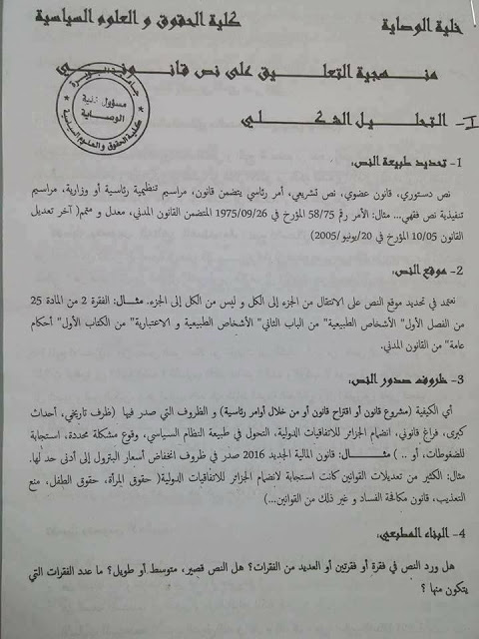](https://1.bp.blogspot.com/-vKxYSkUdE6w/WLGxgmaSWGI/AAAAAAAAQgg/ybla7yCg4Qwx0VTwUh-cGh8SecWrKVOtwCLcB/s1600/1.jpg)**

**[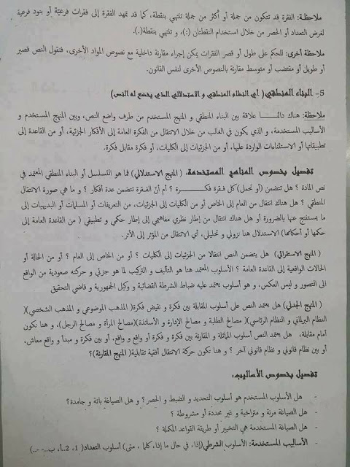](https://4.bp.blogspot.com/-s02l9D49h64/WLGxg8m1SVI/AAAAAAAAQgo/LBx55ugLm_kSUz2qnTN34_8w5gweCGuKgCLcB/s1600/2.jpg)**

**[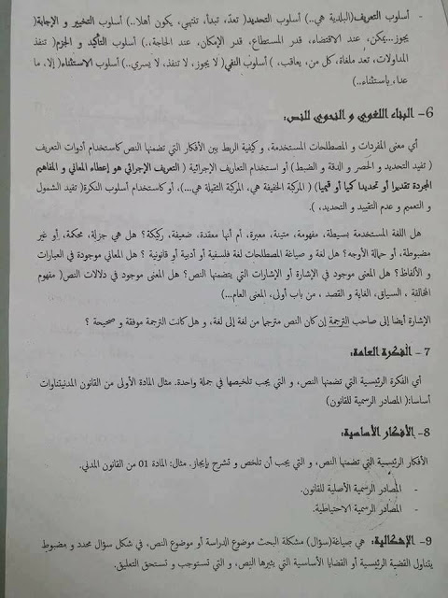](https://4.bp.blogspot.com/-N9gDKmaoYuc/WLGxgkMXR_I/AAAAAAAAQgk/eDw7K3c0Jus4R6WwANICKU08kBf4RE90ACLcB/s1600/3.jpg)**

**[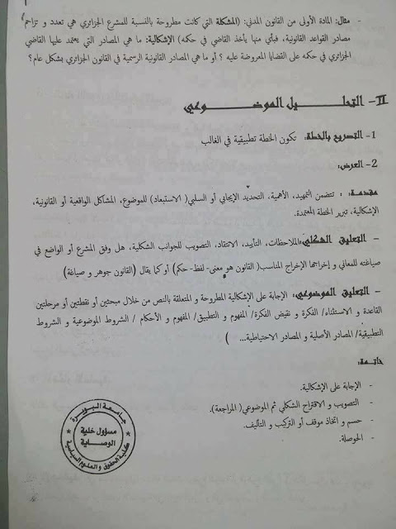](https://2.bp.blogspot.com/-UzmmGIzngE4/WLGxhUaTm5I/AAAAAAAAQgs/ENp_vZ4brygw1aHo4Q9puYXaUjf3S0gzQCLcB/s1600/4.jpg)**