Adverbs

Adverbe: is a word or phrase that modifies or qualifies an adjective, verb, or other adverb or a word group, expressing a relation of place, time, circumstance, manner, cause, degree, etc.
There are 5 different types of adverbs including adverbs of degree, frequency, manner, place and time.

1 Adverbs of Degree
For adverbs that answer “how much” or to “what extent”, they are adverbs of degree. For example, they usually modify other verbs, adjectives or adverbs making them stronger or weaker.

ADVERBS OF DEGREE EXAMPLES:
- He’s very good at playing the piano.
- She’s almost always late arriving at school.
- It’s pretty interesting to see the history of China.
- The English test was extremely difficult.
- When he wears his running shoes, he moves more quickly among everyone.

Adverbs of Frequency
Adverbs of frequency express “how often” something takes place. In other words, it explains the intensity of occurrence that an event happens. Adverbs of frequency are usually in this form: Subject + Adverb + Verb
Adverb of Frequency | How Often
Never | 0%
Hardly Ever | 10%
Rarely | 20%
Seldom | 30%
Occasionally | 40%
Sometimes | 50%
Often | 60%
Frequently | 70%
Usually | 90%
Always | 100%
In addition, adverbs like “daily”, “weekly”, “monthly” and “yearly” describe frequency. But these adverbs of frequency answer “how often” in a more specific way.

ADVERBS OF FREQUENCY EXAMPLES:
- I usually go to the gym on weekends.
- She always wake up at 7:00 am.
- The family rarely eat brown rice for dinner.
- I never take sick days.

3 Adverbs of Manner
Adverbs of manner express how something happens. In most cases for adverbs of manner, you can take an adjective and simply add -ly to form an adverb. For example, if you take take the sentence – “The cat is quick (adjective).”
Instead of describing a noun, an adverb describes or modifies a verb. In this case, the noun is the word ‘cat’. Because adverbs describe verbs, you need to add a verb in the sentence. For example, you can use the verb “to run” in this form – “The cat runs quickly.”

ADVERBS OF MANNER EXAMPLES:
- The cat runs quickly.
- She plays the violin terribly.
- The horse moved fast.
- She plays the piano well.

4 Adverbs of Place
Adverbs of Place describe “where” an action takes place. In addition, we usually find adverbs of place after the main verb.
For example, “indoors”, “next week” and “still” all describe where something happens. Again, we often find these adverbs of place after a verb in a sentence.

ADVERBS OF PLACE EXAMPLES:
- If you want to see the hot air balloon, you will have to go outside.
- When she entered the classroom, she sat down.
searched everywhere but I couldn’t find him.
- He walks downstairs to meet his father.

5 Adverbs of Time
As with all adverbs, they tell us more about the verb. For adverbs of time, they tell us when the verb happened or will happen. For example, “afterwards”, “every day” and “recently’ are adverbs of time and describe “when”.
On the other hand, adverbs of time can describe the duration of an event occurs. Also, it can show when an action is complete.

ADVERBS OF TIME EXAMPLES:
- We’ll go to the festival tomorrow.
- Yesterday, we played in the basketball tournament.
- She’ll eventually finish studying and go to university.
- They ate popcorn and watched movies all day.

Used to vs. Use to
A commonmistakeboth for learners of English as well as native speakers is the differencebetween “Used to” and “Use to” and when (or if) we put the letter D at the end of the verb.
First let’s look at the meaning of it:
Used to = an action or habit thatwascommon in the PAST but not anymore.
This should not beconfusedwith
To beused to = accustomed to something (normally out of habit or experience)
Notice how Used to ends in –ed whichnormallymeans the verbis in the pasttense.
- I used to drink coffee everymorning but now I drink tea.
- She used to live in London but nowshelives in New York.
- He used to play football professionally but hehad to quitbecause of an injury.

Used to inNegative
If wewant to make a negative sentence, the didn’t part shows thatwe are talking about the pasttense.
I didn’t use to likeher but now I thinksheisgreat.
Many times we use never instead of didn’t. In this case we use “used” in pasttense. Compare:
- I didn’t use to smoke.
- I neverused to smoke.

Used to in Questions
As with normal questions in the pasttense, we use the base form of the verb (not the verb in pasttense), since the auxiliary DID shows us that the question is in the pasttense.
- + I used to ride a bike to schooleveryday.
- - I didn’t use to ride a bike to school. I wouldnormally go by bus.
- ? Didyou use to ride a bike to schoolwhenyouwere a child?
Some more examples
- Whatdidyou use to do afterschoolwhenyouwere a kid?
- Wheredidyou use to go on vacation withyour parents?

Why do people sometimeswrite Useto instead of Usedto in English?
Well, whenwesay used to, the final D in the verb used ispronouncedlike a T and since the nextword (TO) alsobeginswith the T sound, itseemslikethereisonly one T (thatbelonging to the word TO).
Whenspeaking, wefrequentlyrunwordstogether (joinwords) soitwouldsoundlike Use-to.

Usedto and Would
Sometimeswecan replace Used to with Would.
- Mygrandfather used to do exerciseseverydaybeforework.
- Mygrandfather would do exerciseseverydaybeforework.

Why the British Always Talk About the Weather
You’ve probably heard that British people ALWAYS talk about the weather. And honestly; it’s true. The British use the weather almost like a greeting; and even manage to mention the weather when they’re not talking about the weather
What’s more, according to Kate Fox’s book “Watching the English”, one third of the country are talking about the weather at any given time. And if that wasn’t enough, the Scots dialect has over 100 different words for rain.
Yet none of this is strange or unusual, it actually makes a lot of sense if you understand how barmy and unpredictable British weather isYou’ll find winters as warm as spring, snow in April, rain in the middle of August and downpours straight after sunshineor both in one day
This unpredictable weather is intrinsically linked to the British character; in fact, it’s unpredictability could be the reason they talk about it. In ancient cultures weather was a serious matter, and often meant the difference between life or death. So, as culture evolved, so did the weather obsession.
And it’s not just Britain. Japan is an island with a similarly erratic climate and the people are equally weather obsessed.
In some situations, weather talk is an icebreaker. In others it’s used to fill awkward silences, or divert the conversation away from uncomfortable topics. Often it’s an excuse for a good old grumble, which can be a bonding experience in itself, but we can also use weather speak to gauge other people’s moods: “Depending on their response to your weather greeting, you can tell if someone is in the mood for a chat, or is feeling grumpy and negative.
Yet it runs deeper. Some nationalities like their conversations to get personal quickly, they like to ask what people do for a living and what age they are; whereas the British don’t. They’re a reserved so a topic like the weather is perfect: not only is it neutral, it’s also something that everyone can agree on.

- More than nine in 10 Brits have talked about the weather in the last six hours. But is this unusualand if so, is it their culture or the climate that makes them so obsessed?

Is the British weather unique in the world?
- does the british use the topic of weather as a way to get into the personal life of others ?
- extract from the text a words that are related to the wather?
- Are the scots similarly obsessed by the weather ?

HOW TO TALK ABOUT WEATHER IN ENGLISH

The Weather in English
In English, we usually use it is when we talk about the weather.
This is normally: It is + adjective OR It is + verb-ing
It is + adjective = A description of the weather
- It is sunny today.
- It's hot and humid today.
- It'sa nice day today.
It is + verb-ing = This type of weather is happening now.
- It's drizzling outside.
- It's snowing.
- Take an umbrella, it's raining.
You can also use it is in different tenses
- It was cold yesterday.
- It will be cloudy tomorrow.
When you are learning vocabulary about the weather, it is important to remember that some of the words have a noun form, a verb form and/or an adjective form. For example:
- Rain: (noun) The game was cancelled because of the rain.
- Rain: (verb) I think it is going to rain later.
- Rainy: (adjective) It's a rainy day.
It pays to learn the different forms of each word and when they are used.
Nouns and Adjectives
Many times when we are talking about the weather, we can add the letter Y to the end of a noun to make it an adjective.
- rain (noun) - rainy (adjective)
- sun (noun) - sunny (adjective)
- wind (noun) - windy (adjective)
- cloud (noun) - cloudy (adjective)
- fog (noun) - foggy (adjective)

Here are some questions you could ask:
- What's it like out(side)?
- How's the weather?
- What's the weather like?
- What's the temperature?
- What's the weather forecast?
- Is it hot or cold? Is it sunny? Is it raining?

Some answers to describe weather:
- Today it is warm and sunny out.
- It’s so cold out there!
- The sun is very bright today, you might want to take sunglasses.
- It's not raining, but it is cloudy.
- It is! I'm so happy the sun is shining.
- They're saying blue skies and hot!

Here is some weather vocabulary that you might use:
- rain: drizzle-rain-flood
- Cold: hail-snow-snowflake
- Clouds: cloudy-foggy-overcast
- Wind: breeze-blustery-windy
below freezing: temperature less than 0 Celcius or 32 Fahrenheit
It's supposed to be below freezing today. I should wear my gloves.
boiling hot: an idiom used to describe a very hot day
It was boiling hot, so we decided to stay inside.
breeze: a very light wind; breezy: lightly windy
chilly: lightly cold
I always wear a scarf when it's chilly.
drizzling: to be raining very lightly
I don't think you'll need an umbrella, it's only drizzling.
overcast: a gray sky with no sun visible

Prepositions "On," "At," and "In"

A preposition is a word that links a noun, pronoun, or noun phrase to some other part of the sentence.

On
Used to express a surface of something Pour indiquer que quelque chose est sur autre chose
- I put an egg on the kitchen table.
- he is working on the floor
- the picture is on the wall
- The paper is on my desk
- there is a dog on the roof
Used to specify days and dates:
- On Monday On Tuesdays On Wednesday evening On Christmas Day
- I was born on the 14th day of June
Used to indicate a device or machine, such as a phone or computer:
- He is on the phone right now.
- She has been on the computer since this morning.
- My favorite movie will be on TV tonight.
Used to indicate a part of the body:
- on my shoulder.
- on my cheek.
- I wear a ring on my finger.
Used to indicate the state of something:
- Everything in this store is on sale.
- The building is on fire.
AT
Used to point out specific time:
- I will meet you at 12 p.m.
- The bus will stop here at 5:45 p.m.
Used to indicate a place:
- At home , at school , at work , at the concert
- There were hundreds of people at the park. at the stadium
- The shop is at 45 Clapham Road (Adresse)
Used to indicate an email address:
- Please email me at abc@defg.com.
Used to indicate an activity:
- I am good at drawing a portrait. at acting. at playing football

In
Used for unspecific times during a day, month, season, year
- She always reads newspapers in the morning. (in morning/in the afternoon/in the evening)
- In the summer, we have a rainy season for three weeks.
- The new semester will start in March.
- WWI started in1914 or in the 18th centry
Used to indicate a location or place:
- In Africa In London In chawton In Main Street
- I am currently staying in a hotel.
- My hometown is Los Angeles, which is in California.
Used to indicate a shape, color, or size:
- This painting is mostly in blue.
- The students stood in a circle.
- This jacket comes in four different sizes.
Used to indicate a belief, opinion, interest, or feeling:
- I believe in God.
- We are not interested in gambling.

Polite requests in English
There are different ways of asking for something. We usually ask for something in a polite and indirect way, for example, using can, could, would you mind if and may:
Asking for something

Can I have the salt? Of course, here you are.
Could I ask you the time, please? No problem. It’s quarter past four
Would you mind if I borrowed your pen, please? Of course, here you are.
May I have the bill, please? (May is more formal.) Certainly, Madam.
I need is very direct and is usually used for urgent requests:
I need a doctor.
I need the fire extinguisher. Fast!
I want is very direct and can sound impolite. We don’t normally use it to make requests unless we want to be very direct:

Asking someone to do something
There are a number of ways of asking someone to do something in a polite and indirect way. We often use please to make our requests more polite:
Could you call a taxi for me, please?
Would you ask Rose whether she has signed the card, please?
Would you mind collecting my suit from the dry cleaner’s, please?
Do you think you could come in ten minutes early tomorrow, before the presentation?
We sometimes use can you and will you to make requests but they are more informal:
Mum, can you wake me at seven o’clock?
Will you send me an email tomorrow just to remind me to book a hotel?
We need is often used in work contexts by a boss or manager to ask for something to be done in a polite way:
We need to email the contract to Peter immediately.
We need someone to go to the meeting in Paris on Wednesday. Bill can’t go.
When we are not sure if someone will be able to do what we ask, we sometimes use you wouldn’t …, would you? or you couldn’t …, could you?:
You wouldn’t drop this into the post office for me, would you?
You couldn’t stop at a bank machine, could you?
In formal letters and formal emails, we can use the following expressions:
I would be grateful if you could send me more information about the course.

Polite requests in English
There are different ways of asking for something. We usually ask for something in a polite and indirect way, for example, using can, could, would you mind if and may:
Asking for something

Can I have the salt? Of course, here you are.
Could I ask you the time, please? No problem. It’s quarter past four
Would you mind if I borrowed your pen, please? Of course, here you are.
May I have the bill, please? (May is more formal.) Certainly, Madam.
I need is very direct and is usually used for urgent requests:
I need a doctor.
I need the fire extinguisher. Fast!
I want is very direct and can sound impolite. We don’t normally use it to make requests unless we want to be very direct:

Asking someone to do something
There are a number of ways of asking someone to do something in a polite and indirect way. We often use please to make our requests more polite:
Could you call a taxi for me, please?
Would you ask Rose whether she has signed the card, please?
Would you mind collecting my suit from the dry cleaner’s, please?
Do you think you could come in ten minutes early tomorrow, before the presentation?
We sometimes use can you and will you to make requests but they are more informal:
Mum, can you wake me at seven o’clock?
Will you send me an email tomorrow just to remind me to book a hotel?
We need is often used in work contexts by a boss or manager to ask for something to be done in a polite way:
We need to email the contract to Peter immediately.
We need someone to go to the meeting in Paris on Wednesday. Bill can’t go.
When we are not sure if someone will be able to do what we ask, we sometimes use you wouldn’t …, would you? or you couldn’t …, could you?:
You wouldn’t drop this into the post office for me, would you?
You couldn’t stop at a bank machine, could you?
In formal letters and formal emails, we can use the following expressions:
I would be grateful if you could send me more information about the course.

Conditionals
What are conditionals in English grammar? Sometimeswe call them 'if clauses'. Theydescribe the result of somethingthatmighthappen (in the present or future) or might have happened but didn't (in the past) . They are made using different English verbtenses.
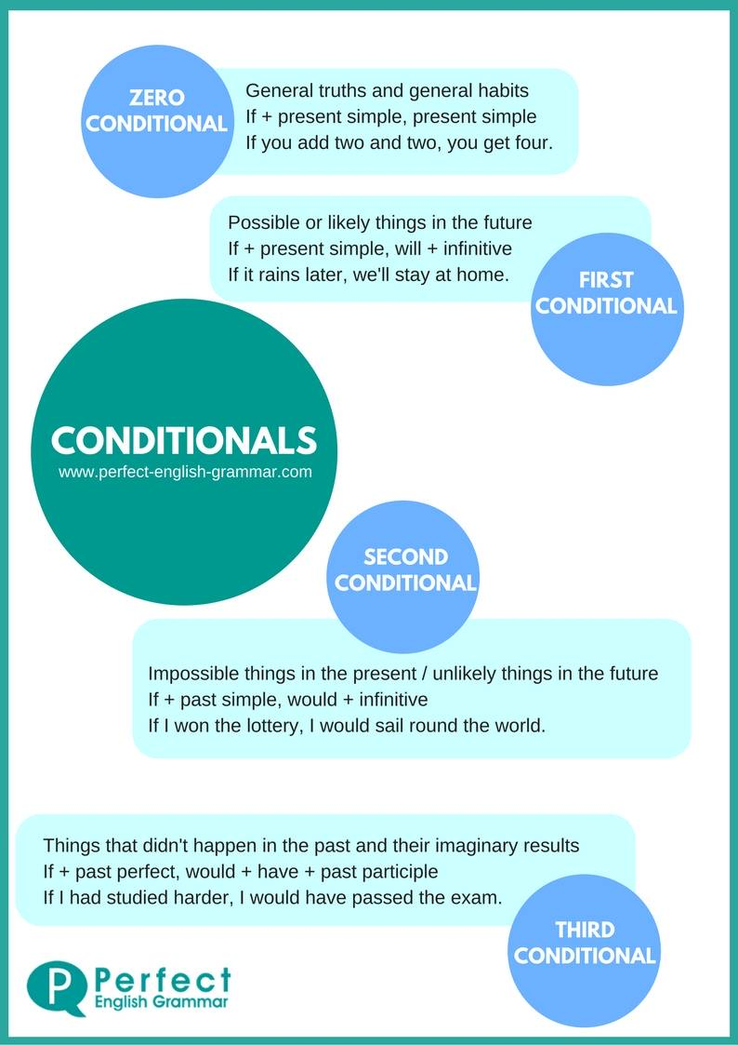
There are four main kinds of conditionals:
- The ZeroConditional:
(if + present simple, ... present simple)
If youheat water to 100 degrees, itboils.
Click here to learn more.
- The First Conditional:
(if + present simple, ... will + infinitive)
If itrainstomorrow, we'll go to the cinema.
- The Second Conditional:
(if + past simple, ... would + infinitive)
If I had a lot of money, I wouldtravelaround the world.
- The ThirdConditional
(if + pastperfect, ... would + have + pastparticiple)
If I had gone to bedearly, I would have caught the train.

