1. **Copier/coller la séquence 1 à partir de CHROMAS**
2. **Copier/coller la séquence 2 à partir de CHROMAS**
3. **Comparer entre séquence 1 et séquence 2 en utilisant BLQST 2seq (**[**https://blast.ncbi.nlm.nih.gov/Blast.cgi?PAGE_TYPE=BlastSearch&BLAST_SPEC=blast2seq&LINK_LOC=align2seq**](https://blast.ncbi.nlm.nih.gov/Blast.cgi?PAGE_TYPE=BlastSearch&BLAST_SPEC=blast2seq&LINK_LOC=align2seq)**)**
4. **Identifier la séquence commune**
5. **Combiner les deux séquences**
6. **Identifier la séquence complète en utilisant le BLAST**

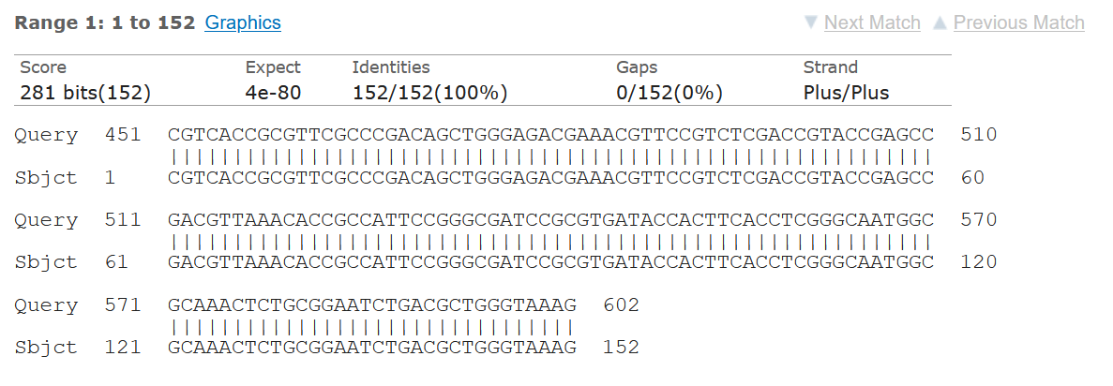

**Sequence 1**

CATGGTTAAAAAATCACTGCGCCAGTTCACGCTGATGGCGACGGCAACCGTCACGCTGTT

GTTAGGAAGTGTGCCGCTGTATGCGCAAACGGCGGACGTACAGCAAAAACTTGCCGAATT

AGAGCGGCAGTCGGGAGGCAGACTGGGTGTGGCATTGATTAACACAGCAGATAATTCGCA

AATACTTTATCGTGCTGATGAGCGCTTTGCGATGTGCAGCACCAGTAAAGTGATGGCCGC

GGCCGCGGTGCTGAAGAAAAGTGAAAGCGAACCGAATCTGTTAAATCAGCGAGTTGAGAT

CAAAAAATCTGACCTTGTTAACTATAATCCGATTGCGGAAAAGCACGTCAATGGGACGAT

GTCACTGGCTGAGCTTAGCGCGGCCGCGCTACAGTACAGCGATAACGTGGCGATGAATAA

GCTGATTGCTCACGTTGGCGGCCCGGCTAGCGTCACCGCGTTCGCCCGACAGCTGGGAGA

CGAAACGTTCCGTCTCGACCGTACCGAGCCGACGTTAAACACCGCCATTCCGGGCGATCC

GCGTGATACCACTTCACCTCGGGCAATGGCGCAAACTCTGCGGAATCTGACGCTGGGTAA

AG

**Sequence 2**

CGTCACCGCGTTCGCCCGACAGCTGGGAGACGAAACGTTCCGTCTCGACCGTACCGAGCC

GACGTTAAACACCGCCATTCCGGGCGATCCGCGTGATACCACTTCACCTCGGGCAATGGC

GCAAACTCTGCGGAATCTGACGCTGGGTAAAGCATTGGGCGACAGCCAACGGGCGCAGCT

GGTGACATGGATGAAAGGCAATACCACCGGTGCAGCGAGCATTCAGGCTGGACTGCCTGC

TTCCTGGGTTGTGGGGGATAAAACCGGCAGCGGTGGCTATGGCACCACCAACGATATCGC

GGTGATCTGGCCAAAAGATCGTGCGCCGCTGATTCTGGTCACTTACTTCACCCAGCCTCA

ACCTAAGGCAGAAAGCCGTCGCGATGTATTAGCGTCGGCGGCTAAAATCGTCACCGACGG

TTTGTAATAGA

**Sequence complete**

CATGGTTAAAAAATCACTGCGCCAGTTCACGCTGATGGCGACGGCAACCGTCACGCTGTT

GTTAGGAAGTGTGCCGCTGTATGCGCAAACGGCGGACGTACAGCAAAAACTTGCCGAATT

AGAGCGGCAGTCGGGAGGCAGACTGGGTGTGGCATTGATTAACACAGCAGATAATTCGCA

AATACTTTATCGTGCTGATGAGCGCTTTGCGATGTGCAGCACCAGTAAAGTGATGGCCGC

GGCCGCGGTGCTGAAGAAAAGTGAAAGCGAACCGAATCTGTTAAATCAGCGAGTTGAGAT

CAAAAAATCTGACCTTGTTAACTATAATCCGATTGCGGAAAAGCACGTCAATGGGACGAT

GTCACTGGCTGAGCTTAGCGCGGCCGCGCTACAGTACAGCGATAACGTGGCGATGAATAA

GCTGATTGCTCACGTTGGCGGCCCGGCTAGCGTCACCGCGTTCGCCCGACAGCTGGGAGA

CGAAACGTTCCGTCTCGACCGTACCGAGCCGACGTTAAACACCGCCATTCCGGGCGATCC

GCGTGATACCACTTCACCTCGGGCAATGGCGCAAACTCTGCGGAATCTGACGCTGGGTAA

AGCATTGGGCGACAGCCAACGGGCGCAGCT

GGTGACATGGATGAAAGGCAATACCACCGGTGCAGCGAGCATTCAGGCTGGACTGCCTGC

TTCCTGGGTTGTGGGGGATAAAACCGGCAGCGGTGGCTATGGCACCACCAACGATATCGC

GGTGATCTGGCCAAAAGATCGTGCGCCGCTGATTCTGGTCACTTACTTCACCCAGCCTCA

ACCTAAGGCAGAAAGCCGTCGCGATGTATTAGCGTCGGCGGCTAAAATCGTCACCGACGG

TTTGTAATAGA